**Project Documentation:**

**House Price Analysis and**

**Prediction**

**Introduction**

This project involves the analysis of house price data and the implementation of an linear regression model to forecast future house prices. The goal is to provide insights into housing market trends and to create a reliable model for predicting future house prices

**Data Overview**

The dataset consists of records with the following columns:

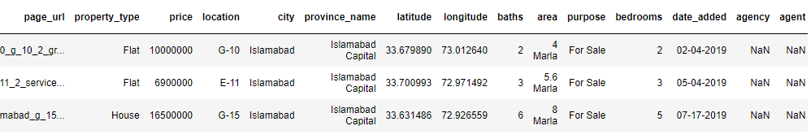

**Data Preprocessing**

1. **Load Data**: The data is loaded into a Pandas DataFrame for analysis.

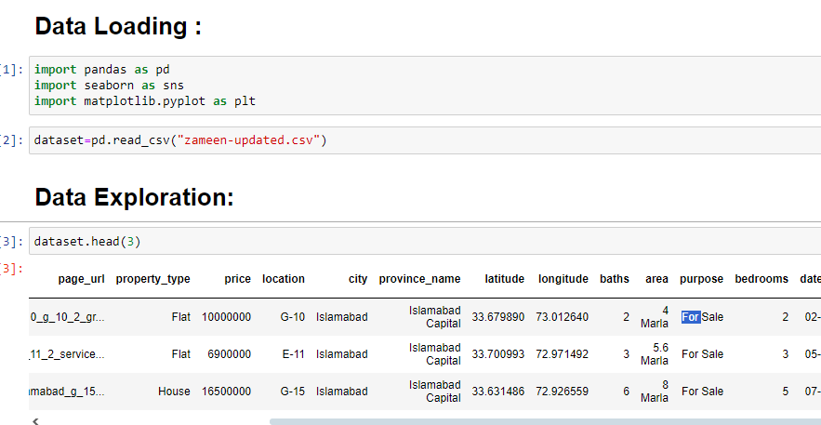

1. **Data Preprocessing:**

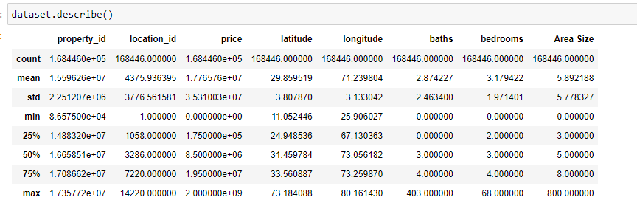

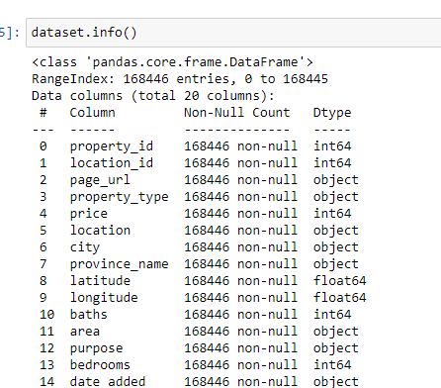

1. **Exploratory Data Analysis And Cleaning:**

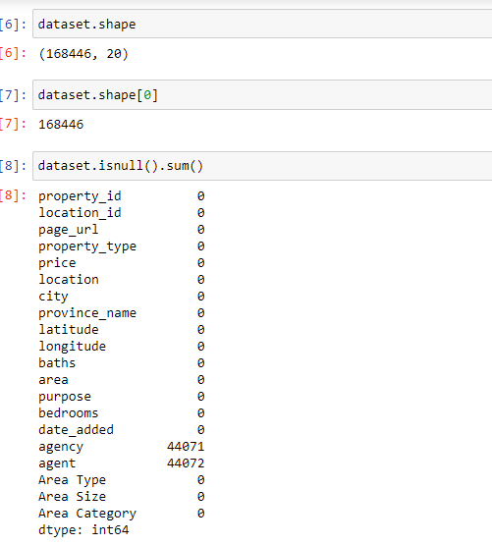

**Identify Null Values:**

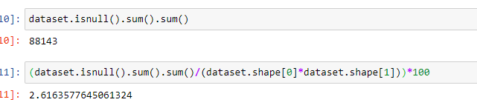

**Visualization:**

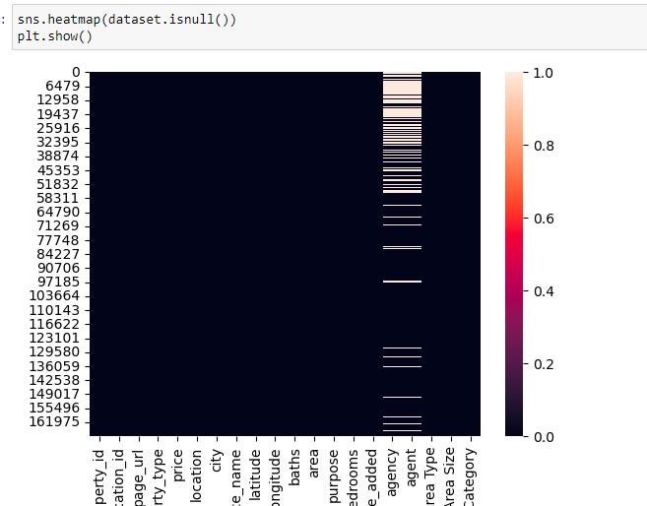

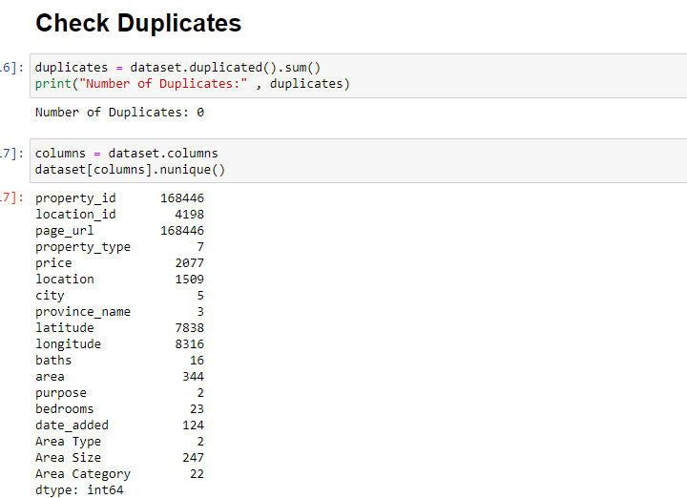

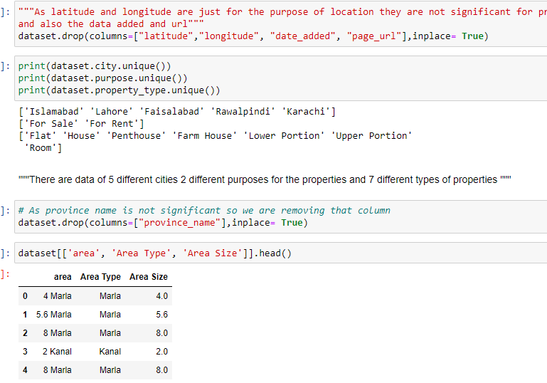

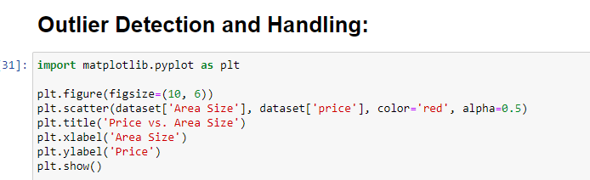

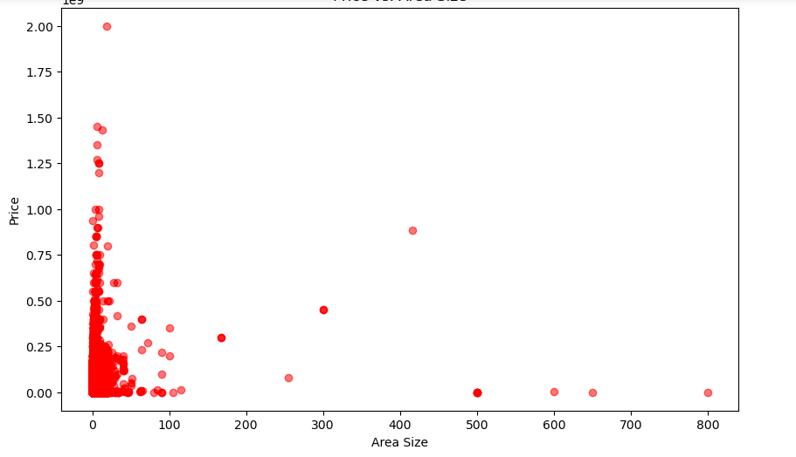

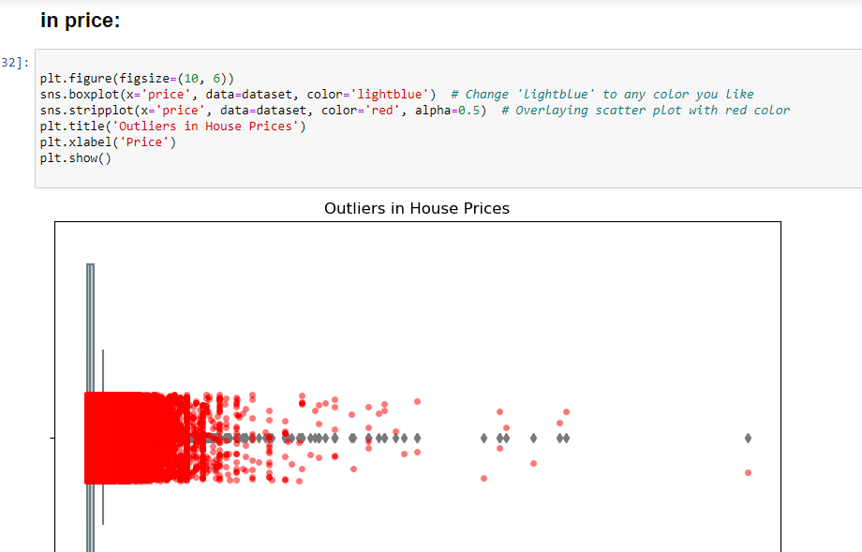

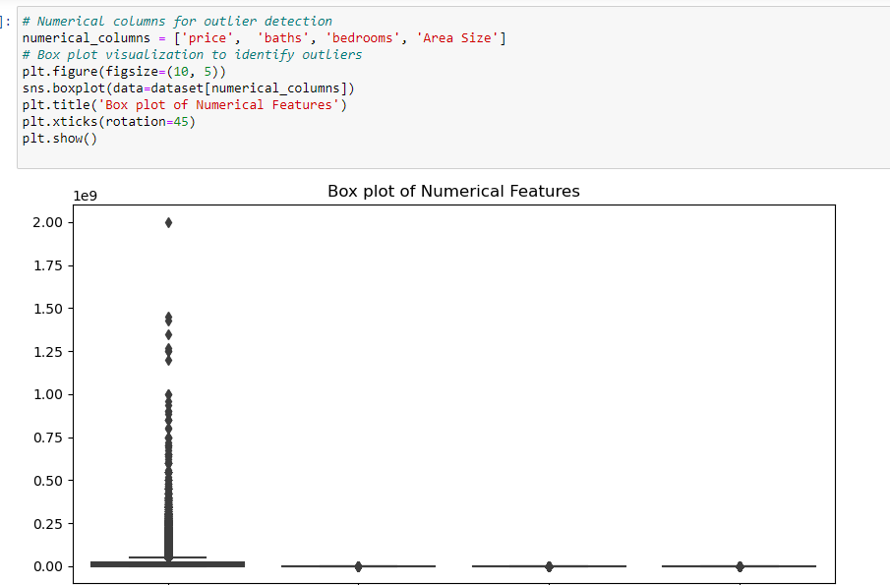

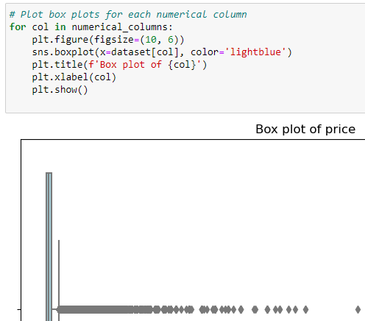

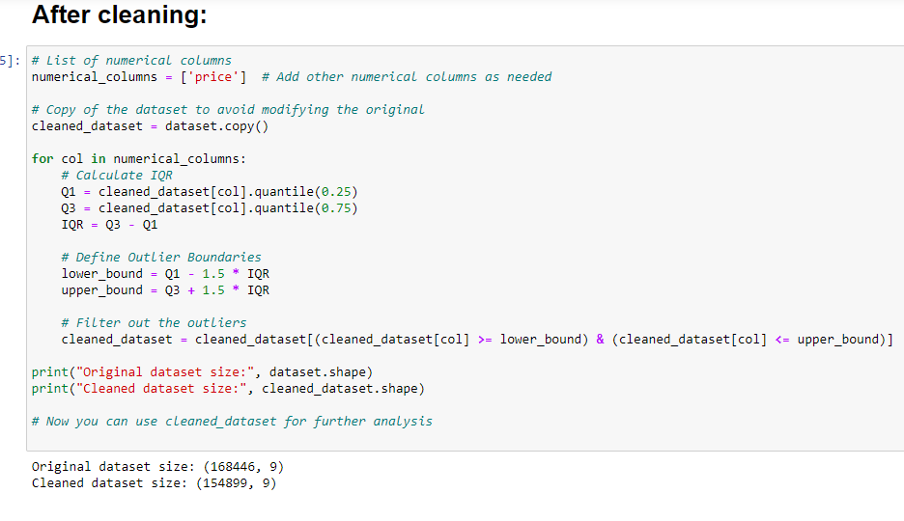

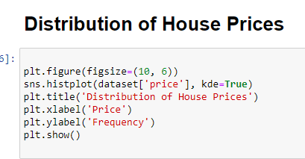

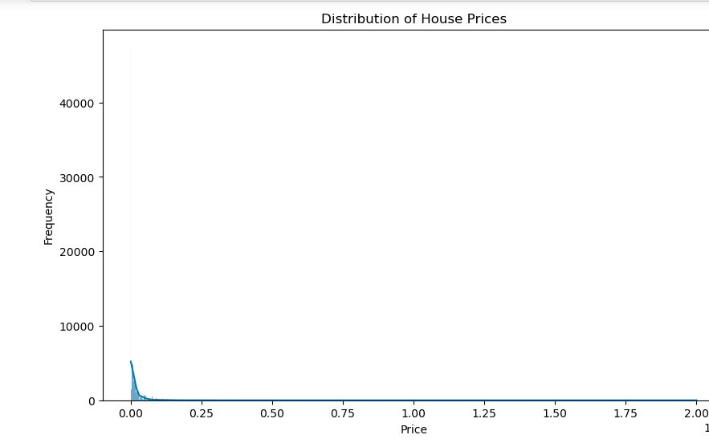

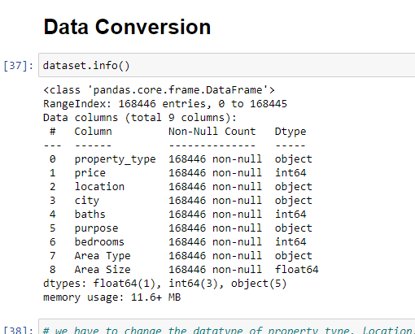

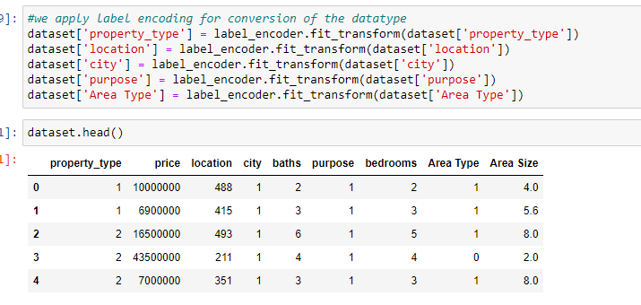

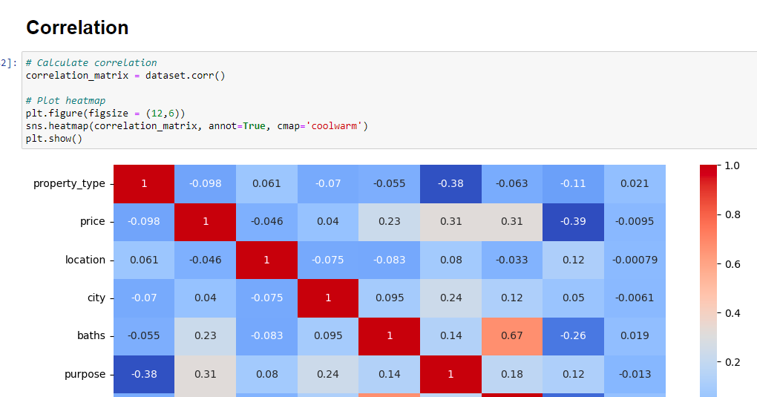

**Model Implementation:**

To find the best straight line to fit all the data points on a graph. The line helps you predict the price of a new house based on its features.

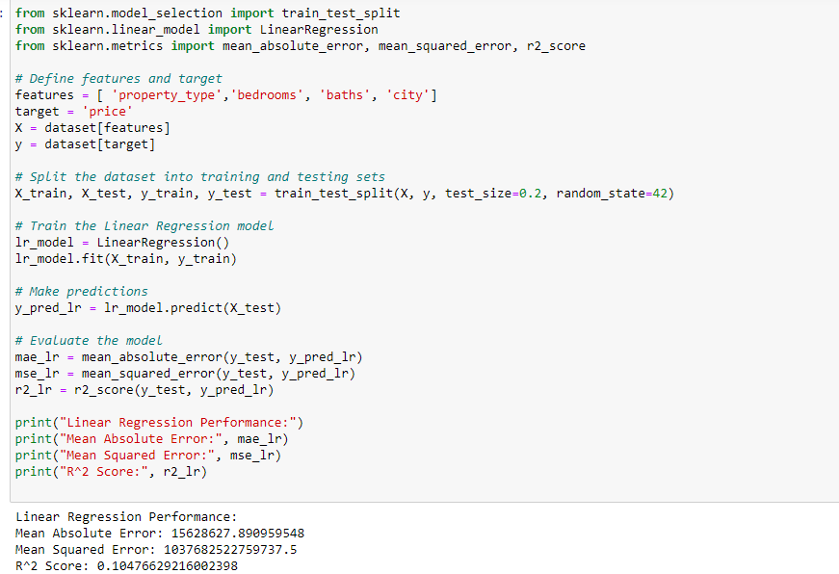

Tools:

* We used Jupyter Notebook.
* Language Python